Version 1.1

08

Fall

CPAQuiz User’s Manual

Table of Contents

1 Introduction 4

2 Features 6

2.1 Easily Create Quiz Page, no HTML coding required 6

2.2 Upload you own image 6

2.3 Easily Define Question and Answers Label 6

2.4 Manage Rewards (CPA Offers) 6

2.5 Built-in Visitor Hit Statistics 6

2.6 Pre Approval Redirect 6

2.7 Unlimited Free Customer Support 6

2.8 No Complicated Installation 6

3 Login and Logout 7

4 Quiz 9

4.1 List Quiz 9

4.2 Quiz Operations 10

4.3 View Quiz 10

4.3.1 The Question Tab 11

4.3.2 The Answer Tab 12

4.3.3 The Reward Tab 12

4.3.4 The Theme Tab 12

4.3.5 Approval Tab 13

4.4 Quiz Operations 14

4.5 Other Quiz Operations 14

4.6 Create New Quiz 15

4.6.1 The Question Tab 16

4.6.2 The Answer Tab 17

4.6.3 The Reward Tab 18

4.6.4 The Theme Tab 19

4.6.5 Approval Tab 20

4.7 Update Quiz 20

5 Reward Management 22

5.1 List Reward 22

5.2 View Reward 22

5.3 Reward Operations 23

5.4 Create Reward 24

5.5 Update Reward 24

5.6 Delete Reward 26

CPAQuiz User’s Manual

Make Easy Money with CPA Simple Quiz Page

# Introduction

With this software you can easily create a Simple Quiz Page, asking visitors to answer a question, which should be a very easy quiz.

The Quiz answers are two choices, example YES or NO, AGREE or NOT AGREE, etc..

After answering the quiz, they will be redirected to the Rewards selection page. Here visitor can choose one of the Rewards you defined on the Reward Admin page, which are actually linked to CPA offers.

Once a Reward is selected, they will be redirected to the CPA offer landing page, and if they complete the required details you will earn money.

It’s that simple ! You are ready to publish the generated quiz page URL to any ads media that you like: email list, CPC, PPV, banner, etc

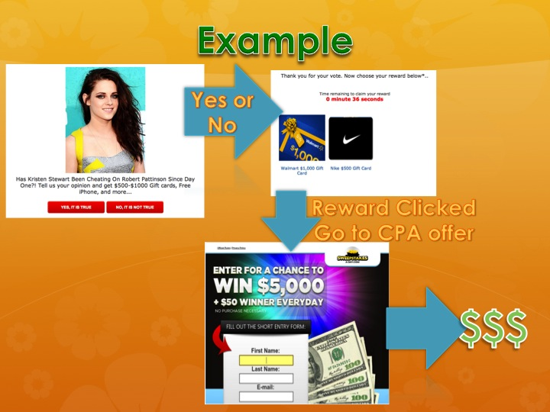

This is an example of how the software works. You create a quiz page asking visitors about their opinion whether Kristen Stewart is cheating on Robert Pattison. They simply need to answer YES on NO.

No matter what the answer is, they will be redirected to a reward selection page where they can select the one they interested. The reward is actually linked to a CPA offer where they need to enter their email and name.

When it’s verified by the CPA vendor, you will make money. Interesting part of CPA is that there’s no refund like in ClickBank, so you can keep the money permanently.

# Features

## Easily Create Quiz Page, no HTML coding required

Just create new page, set question, answer, rewards, image, and publish. No HTML coding is required.

## Upload you own image

Put your own image related to your quiz. Just download from Google Images, save to your local computer and upload to the Quiz Page. Of course you can modify the image first using Photoshop and other photo editing tools, to make it look nicer.

## Easily Define Question and Answers Label

Set the quiz answer, like Yes or No, Agree or Not Agree, etc, depending on your Quiz question.

## Manage Rewards (CPA Offers)

Create rewards to be linked to any Quiz. You can create as many reward as you like. Just make sure that the reward link is correct and linked to your CPA account.

## Built-in Visitor Hit Statistics

See how many visitors clicked your Quiz page, from which IP/host, at what time.

## Pre Approval Redirect

You can setup a public link that will redirect to one of three available actual URL links. The public link is always the same but the actual link is not, you can select which target link you like. This feature is a simple yet very powerful tool for internet marketer that other systems does not offer.

## Unlimited Free Customer Support

Our online support team is always available to help you with questions about your new and existing CPAQuiz installation as long as you are an active user. You can contact us by email or using customer online forum and knowledge base.

## No Complicated Installation

Installation processes is a snap. Simply follow the installation wizard, enter your details, activate the software and you are good to go.

# Login and Logout

When CPAQuiz URL is entered on your browser, a login page will be shown up, for example:

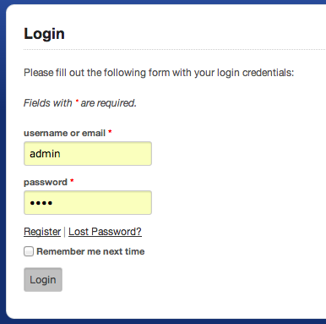

CPAQuiz comes up with two sample users with the following info:

* Username **admin**, password **1234**. This user has root permission that can access all modules: the administration pages and the auto responder pages.
* Username **daniel**, password **1234**. This user has regular user permission that can’t access the administration pages.

Click **Login** button to login to the system. You can see the main menu bar on top, and the main dashboard.

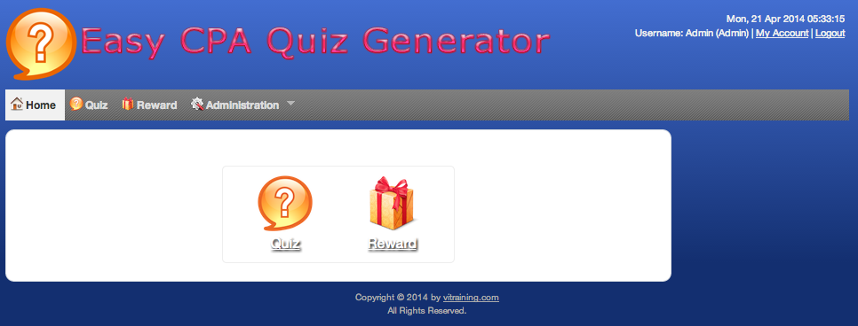

The main menu bar consists of the main functionality of the software.

The **Home** menu is used to go back to the home page showing the dashboard.

The **Quiz** menu is used to manage your quiz pages.

The **Reward** menu is used to manage your quiz rewards.

The **Administration** menu is used to manage your profile, users, groups, modules, and the application settings.

To logout from the system, click the **Logout (username)** menu.

# Quiz

## List Quiz

Click on the menu **Quiz** to manage your quiz.

A page like the following will be shown.

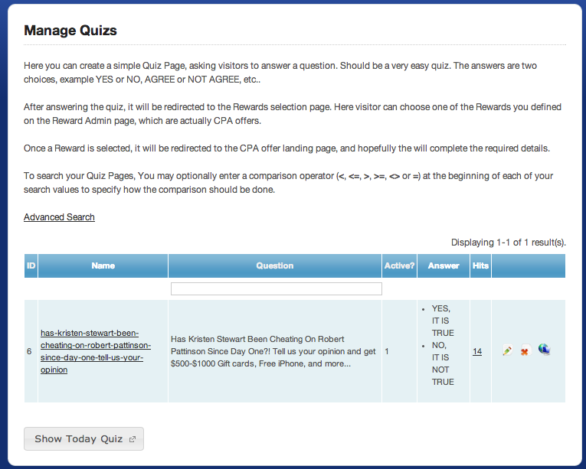

On that page you can see a table that contains the list of Quizzes you already have. The table has several columns: ID (the ID of the Quiz), the Name of the Quiz, the Quiz Question, Active Status, Answers, and the total number of Hits.

To sort the list by a column, simply click on the table column header.

The Show Today Quiz button is used to open the link of the latest active quiz. This link is useful to publish only a single URL but with dynamic page.

## Quiz Operations

On the Quiz List table, you can find two icons for Updating and Deleting the Quiz.

On the right side of the Quiz List page, you can see other Quiz operations menu.

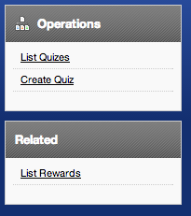

This right menu consists of:

Basic Operations:

* **List Quiz** to go back to the Quiz list
* **Create Quiz** to create a new Quiz

Related Operations:

* **Rewards** to manage the available Rewards

## View Quiz

To view the Quiz details, click on the Quiz Name column.

To view the hit statistic of the Quiz, click the number on the Hits column.

If you click a Quiz Name, a page like the following will be shown.

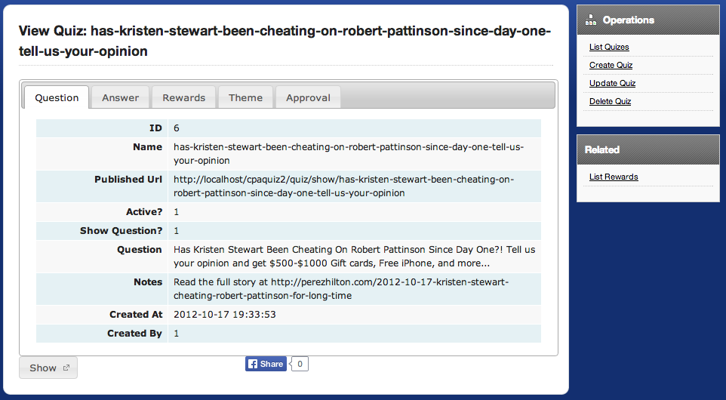

It has several tabs that organize the Quiz details.

### The Question Tab

This tab shows the Quiz’s description. This info will be shown at your Quiz Page along with the Quiz Title.

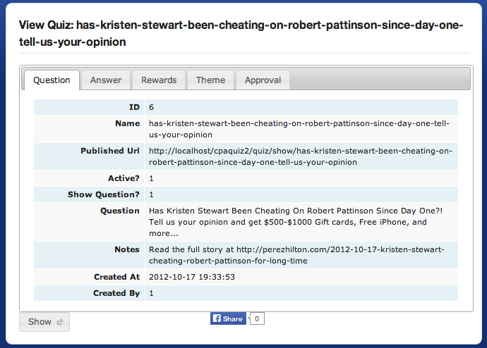

### The Answer Tab

This tab shows you the answer in details.

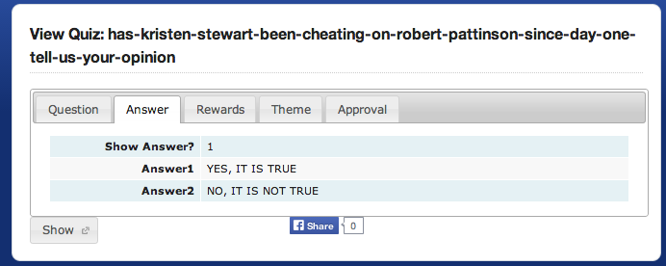

### The Reward Tab

This tab shows you the currently selected Reward for the Quiz’s Page.

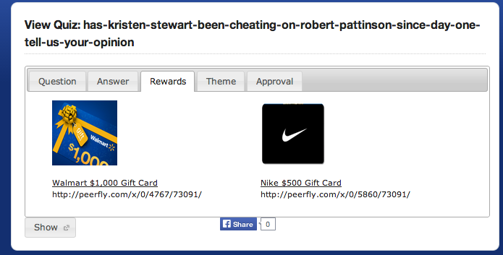

### The Theme Tab

This tab shows you the URL to be opened after the Member successfully confirmed they subscription.

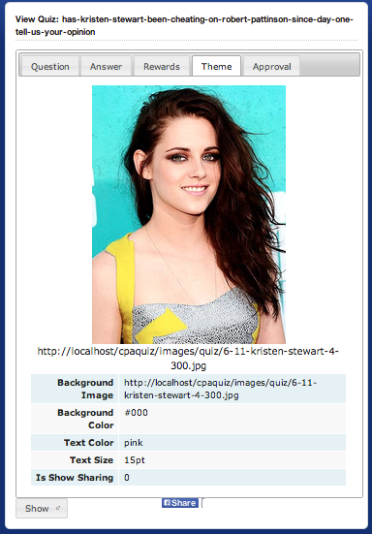

### Approval Tab

If you are advertising the Quiz Page using PPC (Facebook, Adwords, etc) and they need to approve before it’s live, you can put a dummy URL for approval (like Youtube video, etc). Once approved, you can easily change the URL to your Quiz Page.

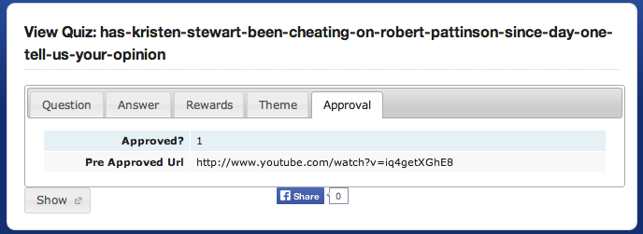

Before your link is approved, it will be redirected to the Pre Approved URL not to your actual Quiz Page. Just put any URL that relevant to your ads content. Anyone’s YouTube Videos will get approved easily. Once the ad is approved, simply tick the Approved checkbox, and the link will go to the actual Quiz Page.

For those who always been rejected by FB AME, this feature is for you!

## Quiz Operations

At the bottom of the Quiz View page, you can see some operation buttons as follows:



Click **Show** button to show the Quiz’s Page URL.

Click **FB** **Share** button to share the URL to your Facebook timeline or Fan page.

## Other Quiz Operations

On the right side of the Quiz View page, you can see other Quiz operations menu.

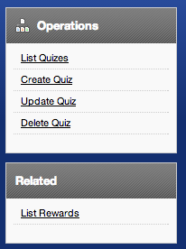

This right menu consists of:

Basic Operations:

* **List Quiz** to go back to the Quiz list
* **Create Quiz** to create a new Quiz
* **Update Quiz** to update the currently viewed Quiz
* **Delete Quiz** to delete the currently viewed Quiz

Related Operations:

* **Rewards** to manage the available Rewards

## Create New Quiz

To create a new Quiz, click on **Create Quiz** link either from the right menu of the Quiz List page or the Quiz View page.

A page like the following will be shown.

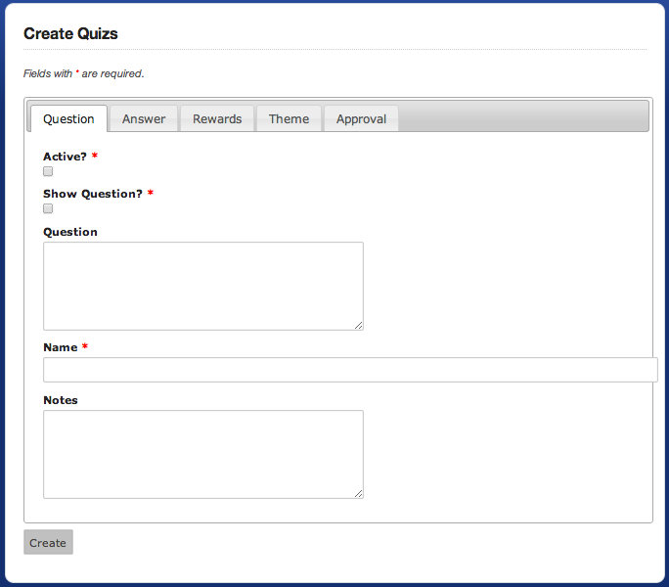

On that page you should fill all mandatory fields marked with a red star.

Click the **Create** button to create the Quiz.

This page has several tabs that organize the Quiz details:

### The Question Tab

This tab shows the input boxes for Quiz’sbasic information.

**ID** is the internal ID.

**Name** is the unique name of your quiz. It is automatically generated based on the question.

**Published URL** is the quiz public URL. This is the created link for the quiz for you to put into your advertising media like email list, PPV, PPC, etc. Example: http://localhost/cpaquiz2/quiz/show/has-kristen-stewart-been-cheating-on-robert-pattinson-since-day-one-tell-us-your-opinion

**Active**? Whether the quiz is active or not.

**Show Question**? Whether to show the question text on the page.

**Question** is the actual quiz question to ask to the visitors. Example “Has Kristen Stewart Been Cheating On Robert Pattinson Since Day One?! Tell us your opinion and get $500-$1000 Gift cards, Free iPhone, and more...”

**Notes** is the additional notes to show at the footer of the page. Exmaple “Read the full story at http://perezhilton.com/2012-10-17-kristen-stewart-cheating-robert-pattinson-for-long-time”

**Created At** is the date and time of the quiz is created.

**Created By** is the user id who created the quiz.

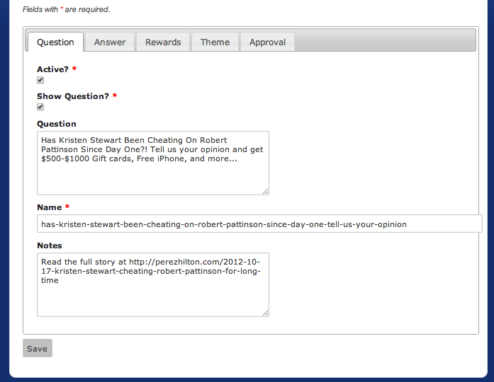

### The Answer Tab

This tab shows you the answer in details:

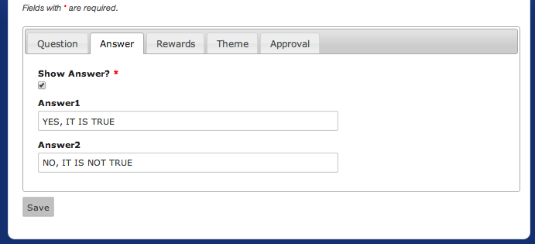

**Show Answer**? Whether to show the answers on the quiz page.

**Answer1** is the first answer. Example “YES, IT IS TRUE”

**Answer2** is the second answer. Example “NO, IT IS NOT TRUE”

### The Reward Tab

This tab shows you the selection of the Rewards (image, actual CPA link, and Title) for the Quiz Page.

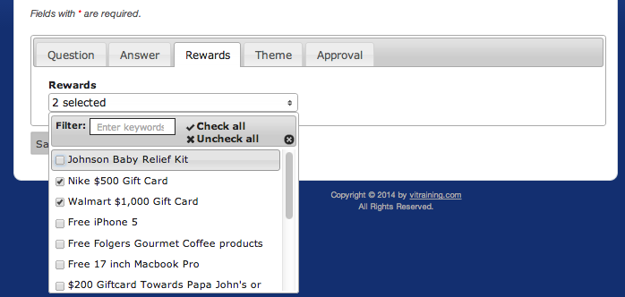

Click on the Rewards that you want to give to this quiz.

To manage Rewards, go to Rewards Management section.

### The Theme Tab

This tab shows you the theme colors and image for the quiz page.

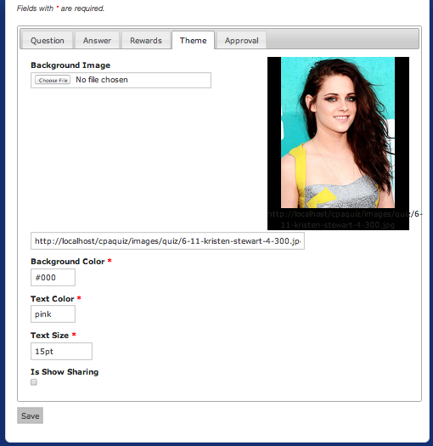

**Background Image** is the background image for the quiz page. Example “http://localhost/cpaquiz/images/quiz/6-11-kristen-stewart-4-300.jpg”. To upload an image, click Choose File button.

**Background Color** is the background color of the quiz page. Example “#000”

**Text Color** is the text color of the quiz page. Example “pink”

**Text Size** is the text size of the quiz page. Example “15pt”

**Is Show Sharing** whether to show Facebook sharing button at the quiz page. Example 0 for not, 1 for yes.

### Approval Tab

This is for setting the URL before your page is approved when you put it into PPC networks that requires approval (Facebook, Adword, for example).

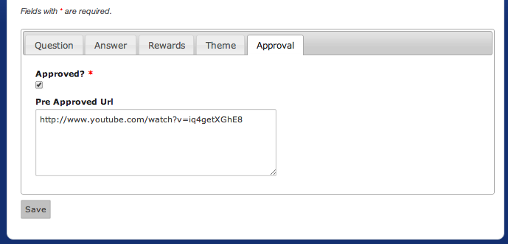

**Approved** is ticked when your Quiz Page is approved by the ad media. Un-tick it when it’s not approved yet. Your page will be redirected to the URL you specified at the Pre Approved URL.

**Pre Approved URL** is for the URL to be redirected when your Quiz Page is not approved yet.

## Update Quiz

To update a Quiz, from the Quiz List, click on the **Update** icon to update a Quiz.

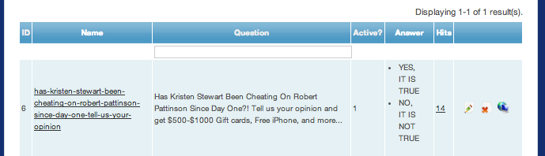

A page like the following will be shown.

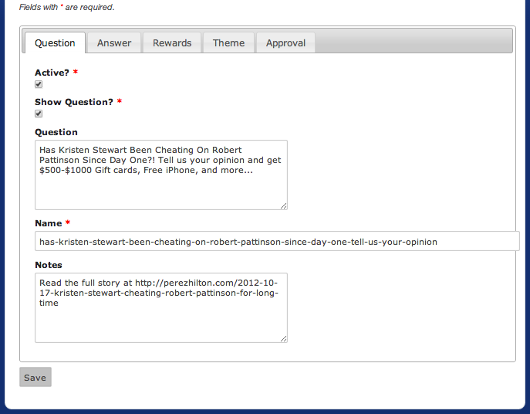

All field information and tabs are the same as the Create Quiz page.

To save the updates, click on the **Save** button.

# Reward Management

## List Reward

Click on the menu **Reward** to open the Reward list.

A page like the following will be shown.

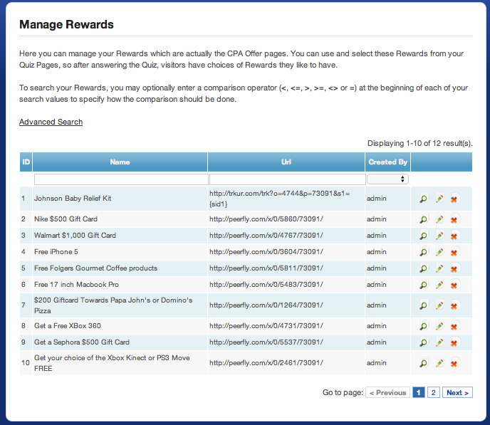

On that page you can see a table that contains the list of Rewards currently defined on your system. The table has several columns: the internal ID, the Reward Name, the URL, and Created By.

On the right most columns you can see some icons to **View**, **Update**, and **Delete** the Reward.

## View Reward

To View the Reward details, click on the **View** icon on the Reward List table.

A page like the following will be shown.

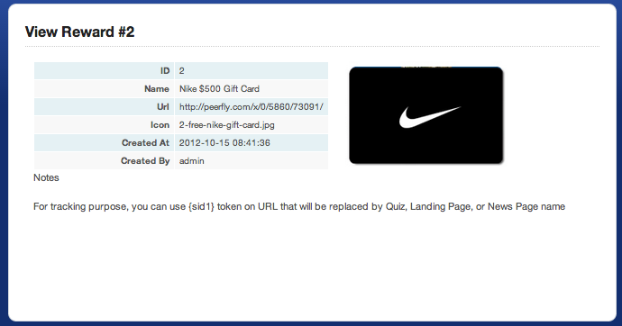

This page shows the details information of a Reward and the preview of the Icon image for the Quiz form, the Name, URL, Notes, the Creator, and the Created Date.

## Reward Operations

On the right side of the Reward view page, you can see the Reward operations menu.

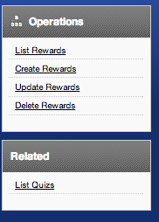

This right menu consists of:

Basic Operations:

* **List Reward** to go back to the Reward list
* **Create Reward** to create a new Reward
* **Update Reward:** to update the currently viewed Reward detail information
* **Delete Reward:** to delete the currently viewed Reward

Related Operations:

* **List Quiz** to go back to the Quiz list

## Create Reward

To create a new Reward, click on **Create Reward** either from the right menu of the Reward List page or the Reward View page.

A page like the following will be shown.

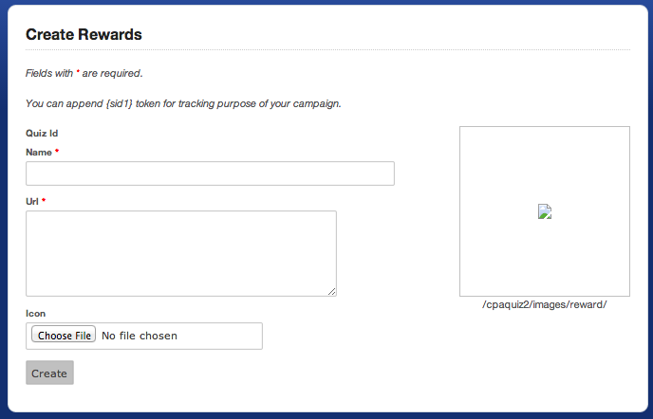

On that page you must enter the following information. The fields those have red star sign are mandatory.

**Name**: the Message name.

**URL**: the URL of the CPA offer for this reward.

**Icon**: choose the background image for the template. It must be in JPG or PNG format.

Click the **Create** button to create the new Reward.

## Update Reward

To update a Reward, from the Reward List, click on the Update icon.



A page like the following will be shown.

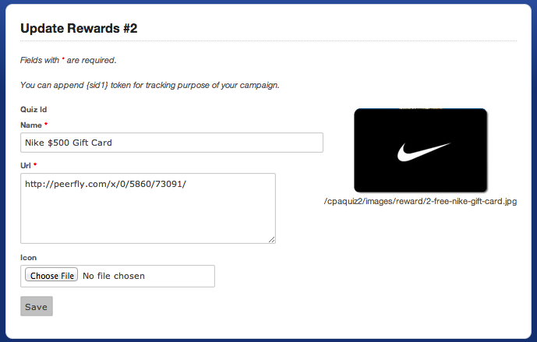

On that page you can update the following information. The fields those have red star sign are mandatory.

**Name**: the Reward name.

**URL**: the URL of the CPA offer for this reward.

**Icon**: choose the background image for the template. It must be in JPG or PNG format.

Click the **Save** button to update the Reward.

## Delete Reward

To delete a Reward, from the Reward List, click on the **Delete** icon.



A confirmation box will appear to confirm you for the deletion. Once deleted, it cannot be undelete.